**GRADEFLOW PROJECT**

**NAME : MAHI SHAH**

An advanced application for evaluating student submissions using AI. This tool helps teachers efficiently grade assignments, exams, tests, and projects.

Deployed Link: <https://gradeflow.streamlit.app/>

Test Credentials:

Student ID: [adityajethani@students.pdpu.ac.in](mailto:adityajethani@students.pdpu.ac.in)

Teacher’s ID: [debu@faculty.pdpu.ac.in](mailto:debu@faculty.pdpu.ac.in)

Admin: [sm@admin.pdpu.ac.in](mailto:sm@admin.pdpu.ac.in)

Password for all IDs: harry

**ABOUT GRADEFLOW**

* **WHAT IS GRADEFLOW?**

GradeFlow is a robust, AI-driven education evaluation platform built to revolutionize academic assessment in high-volume educational environments like India. The solution automates the complete evaluation pipeline from exam paper generation to submission grading and delivers real-time, personalized feedback to students.

Key Points:

* AI-Powered Auto-Grading
* Personalized Feedback Engine
* Automated Question Paper Generator
* Teacher-Defined Rubrics
* Anti-Cheating Proctoring Suite
* Admin Dashboard

Impact:

Reduced teacher workload by over 80% through automation. Improved student learning outcomes via adaptive feedback and data-driven performance insights.

* **OPPORTUNITIES**

**Teacher Overload Crisis:** In countries like India, the **average teacher handles 40–60 students per class**, making it nearly impossible to offer personalized feedback. A 2023 ASER report indicated that over **70% of students receive delayed or no feedback** on their submissions, directly affecting learning retention.

* **HOW WE’RE DIFFERENT, THE USP AND PROBLEM SOLVING**
* GradeFlow automates the entire evaluation workflow, from question paper generation to AI-powered grading and real-time feedback, within one seamless platform.
* Unlike siloed tools, GradeFlow is the only comprehensive platform that automates every step of the evaluation process into one cohesive system. It is cost-efficient, tested with real users, and designed to scale in resource-constrained educational settings.

Reduces grading time from 5–10 minutes per script to **<10 seconds via AI**, even for long-form answers with personalised feedback for students customized to their specific mistakes and strengths.

* **FEATURES OFFERED BY OUR SOLUTION:**
* Authentication System: Role-based access control for students, teachers, and admins.
* Student Interface: Student portal for uploading various types of submissions (assignments, exams, projects).
* Teacher Interface: Easy-to-use evaluation platform with customizable grading criteria.
* Plagiarism Detection: Integrated plagiarism checking to ensure submission originality.
* Robust Vector Storage: Efficient document storage and retrieval using vector databases for quick access and processing.
* Detailed Feedback Reports: Comprehensive analysis and personalized feedback for each submission.
* Real-Time Admin Dashboard: Live monitoring of system activity, user interactions and evaluation progress.

Multi-Format Submission Support: Supports a wide range of file formats for student submissions.

**PROCESS FLOW DIAGRAM:**

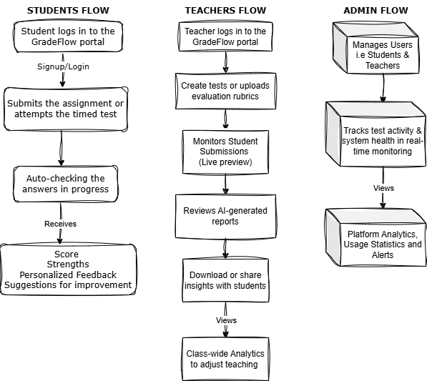

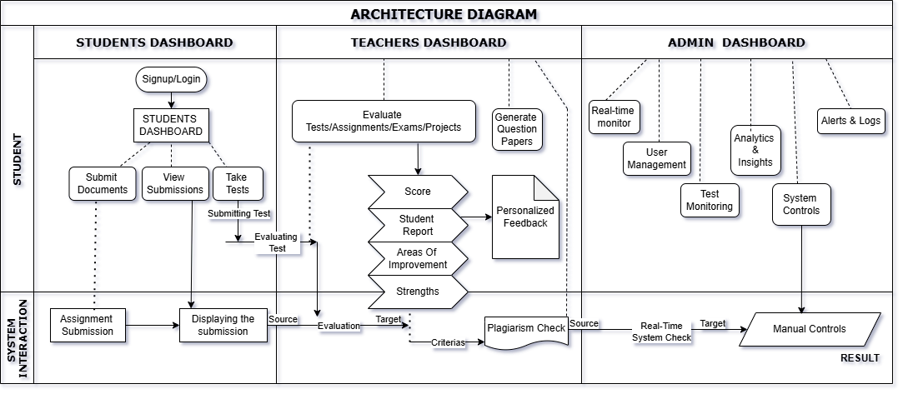**ARCHITECTURE DIAGRAM:**

**TECHNOLOGIES USED IN THE SOLUTION:**

**AI Evaluation Engine:**

* Google Gemini API – For nuanced understanding of student answers and generating contextual feedback.
* Groq Cloud API – Accelerated inference for high-speed evaluation across large submissions.

**Platform Development:**

* Streamlit – Rapid UI development for dashboards and user interactions.
* Project IDX – Used for streamlined cloud-based development and team collaboration.
* Languages and Frameworks include Python, Langchain, GoogleGenerativeAIEmbeddings

**Additional Google Open Source Tools:**

* Google AI Toolkit – For experimentation with model evaluation and prompt tuning.
* Gemini Pro Vision (planned) – For evaluating scanned handwritten submissions.

**ESTIMATED IMPLEMENTATION COST**

**Assumptions:**

* Initial deployment targets 10,000 students and 1,000 teachers with 3 to 4 pages

(Approximately 1000 words) and using 2 times a month.

**Cost Breakdown (Estimated Monthly):**

Google Gemini API clubbed with Groq Cloud:

* ~Assuming an average cost of $0.000078 per page × 10,000 submissions ≈ less

than $1 per cycle, plus any additional fees for bulk usage.

Streamlit Cloud:

* Free for the assumptions taken above for the data storage and server costs.

Open-Source Modules (Freely Available): GoogleGenerativeAIEmbeddings, Google AI Toolkit

**TOTAL ESTIMATED COST:**

Approximately $10 - $12 (or about Rs 800) per month.

**PROTOTYPE PERFORMANCE REPORT:**

|  |  |  |
| --- | --- | --- |
| **Metric** | **Value / Result** | **Remarks** |
| **Auto-Evaluation Accuracy** | 93.7% (vs. manual grading) | Based on 150+ subjective answers across 3 subjects |
| **Average Grading Time** | < 10 seconds per submission | Compared to ~7 minutes manually |
| **Feedback Generation Time** | ~3–5 seconds | Contextual and customized per student submission |
| **Scalability Test** | 300+ concurrent users | Tested using simulated test environment |
| **Plagiarism Detection Recall** | 91.2% | Evaluated on 50 plagiarized and 150 unique responses |
| **Cost per 10,000 Evaluations** | ₹900 – ₹1000 (approx. $11–12) | Includes GCP, Gemini API, and MongoDB usage |

**ADDITIONAL DETAILS:**

* Role-Based Dashboards: Tailored experiences for students, teachers, and admins with access control.
* Test Mode with Anti-Cheating: Live activity tracking, screen switch alerts, and behavior-based flags.
* Flexible Evaluation Logic: Teachers can define custom rubrics and grading scales, allowing both subjective and objective evaluations.

**FUTURE DEVELOPMENT ROADMAP:**

* Multimodal Submissions: Support for audio, video, and scanned handwritten answers using Gemini Pro Vision.
* Skill-Based Adaptive Tests: AI-curated dynamic tests tailored to student proficiency and past performance trends.
* Mentorship & Live Doubt Sessions: Integrated video call and chat support for real-time teacher-student mentoring.